Que 1. How do project the name and the third hobby using $arrayElemAt?

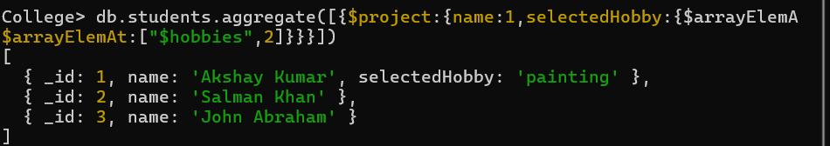

Que 2. Write a query to display each students name along with their top (first) hobby from the list of hobbies.

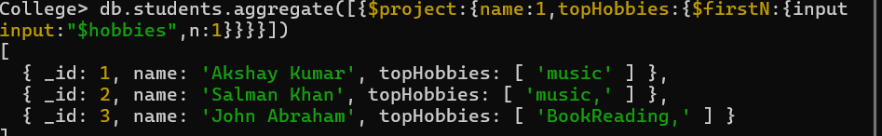

Que 3. How can you retrieve the first hobby of each student using $firstN?

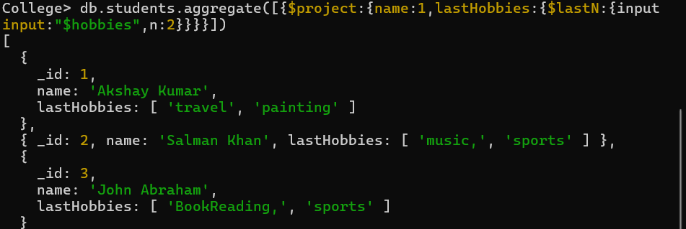

Que 4. How can you retrieve the last hobbies from a student’s hobby list using $lastN?

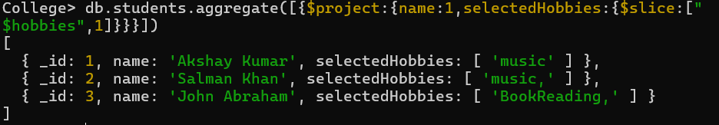

Que 5. How can you retrieve all hobbies starting from the second element using $slice with one argument?

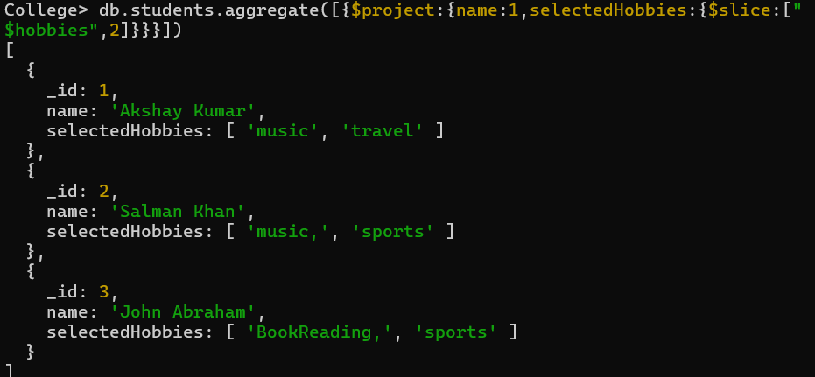

Que 6. How do you retrieve the first two hobbies from a list using $slice with two arguments?

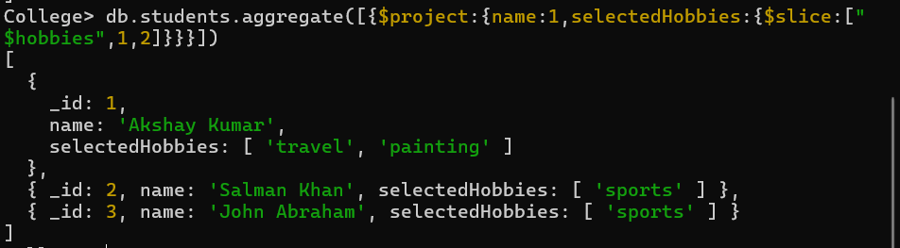

Que 7. How do you retrieve the first two hobbies from a list using $sortArray with two arguments?

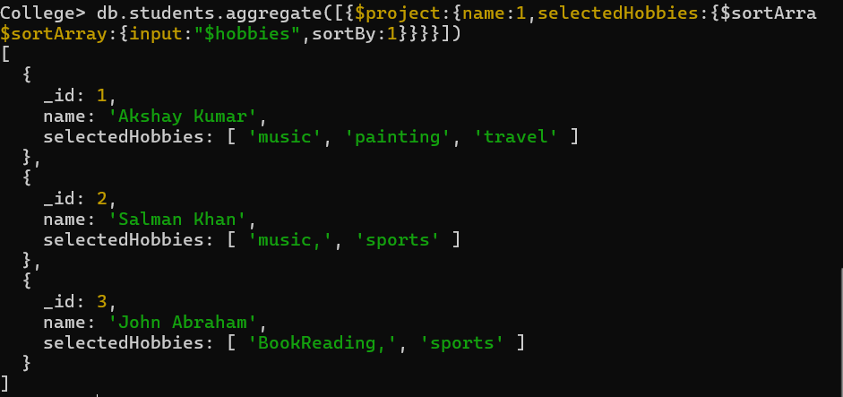

Que 8. How can you sort a student's marks array in ascending order using $sortArray?

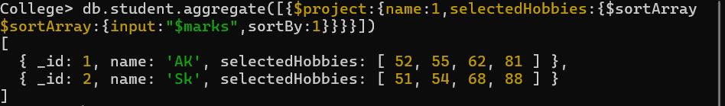

Que 9. How can you reverse the order of elements in a hobbies array using $reverseArray?

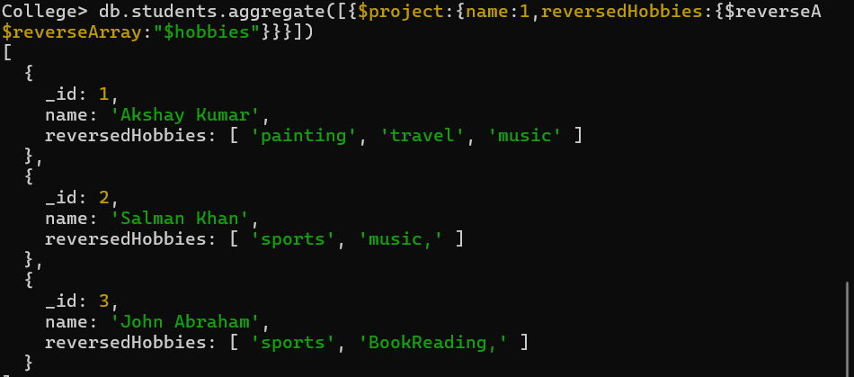

Que 10. How can you count the number of hobbies for each student using $size?

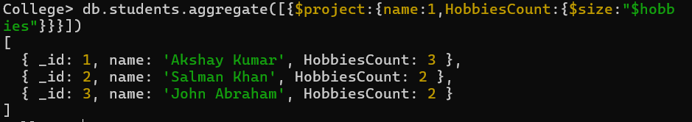

Que 11. How do you check if a specific hobby exists in the hobbies array using $in?

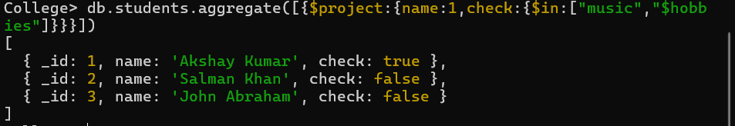

Que 12. **How can you find the index of an element within the hobbies array using $indexOfArray?**

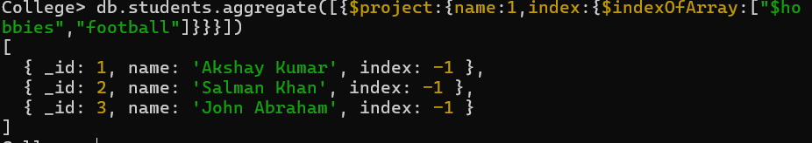

Que 13. How can you search for an element within a specific range of indices using $indexOfArray with optional parameters?

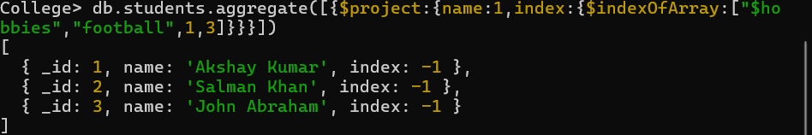

Que 14. How do you retrieve the highest mark from the marks array using $maxN?

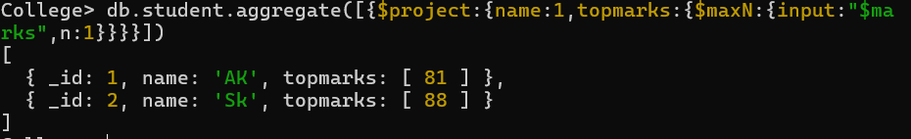

Que 15. How do you retrieve the two lowest marks from the marks array using $minN?

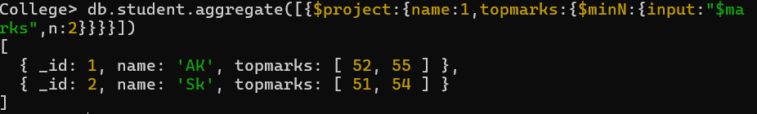

Que 16. How do you check if a field is an array using $isArray?

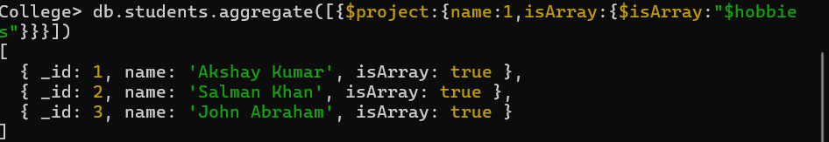

Que 17. How do you check if a non-array field like a name is an array using $isArray?

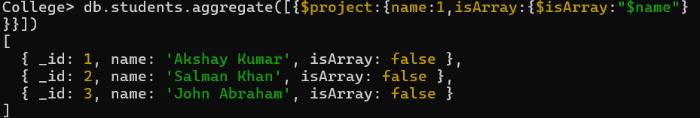

Que 18. How can you convert all elements in a hobbies array to uppercase using $map and $toUpper?

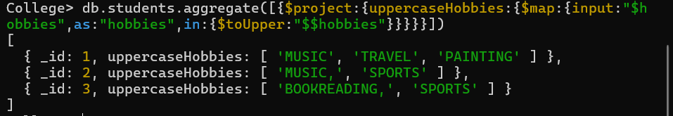

Que 19. How do you increment each element in the marks array using $map and $add?

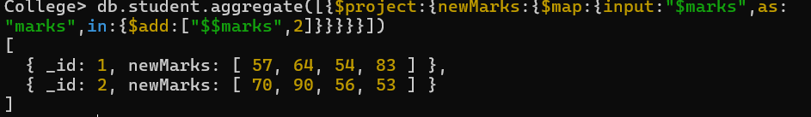

Que 20. How do you filter elements in the marks array greater than or equal to 60 using $filter with limit?

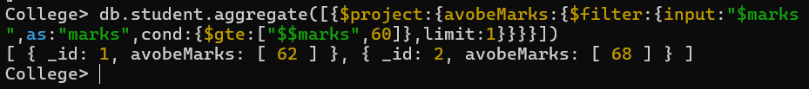

Que 21. How do you calculate the total of all marks using $reduce?



Que 22. How do you concatenate all elements in the hobbies array into a single string using $reduce and $concat?

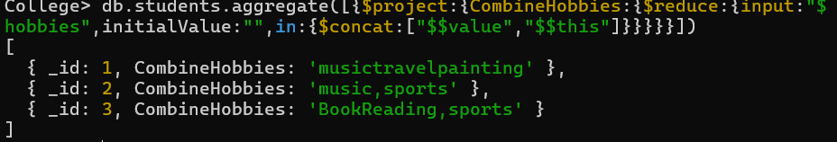

Que 23. How do you combine two arrays like subject and extraSubject into one using $concatArrays?

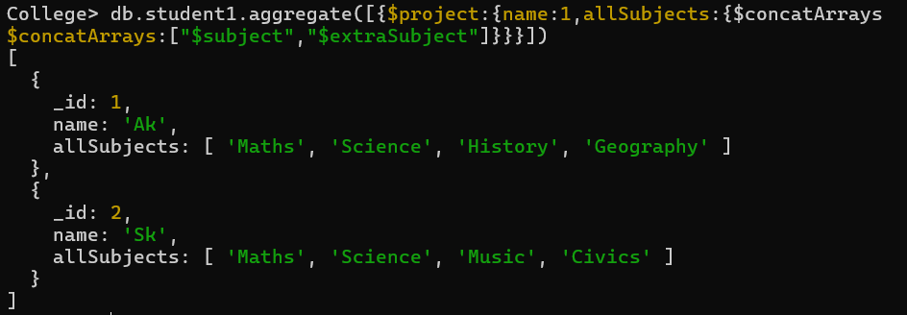

Que 24. How do you zip two arrays (e.g., subjects and marks) into an array of pairs using $zip?

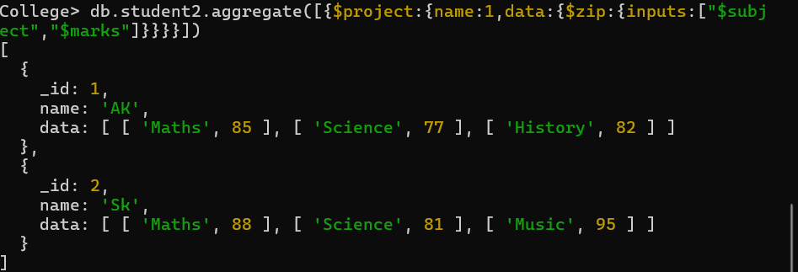

Que 25. • **How do you convert an array of key-value pairs into an object using $arrayToObject?**

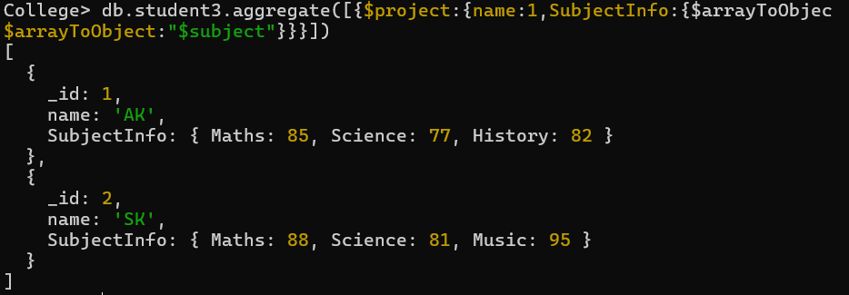

Que 26. How do you convert an object into an array of key-value pairs using $objectToArray?

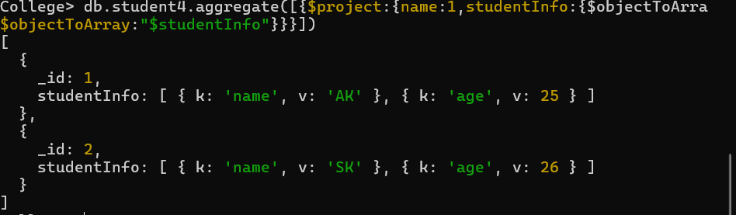

Que 27. How do you categorize a product based on price using $cond (e.g., Expensive vs. Affordable)?

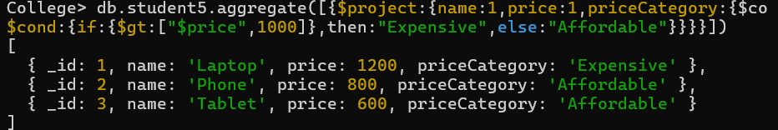

Que 28. How do you apply a discount to the price conditionally using $cond?

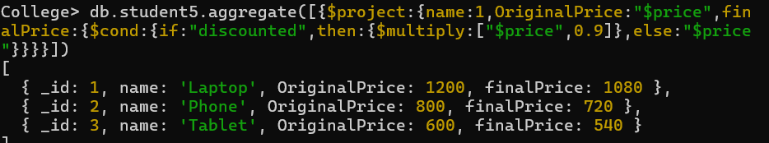

Que 29. How do you handle missing email values by providing a default using $ifNull or $cond?

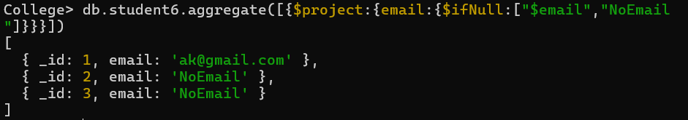

Que 30. Write a query to combine documents from the student collection with those from the personal collection.

